RESULTS AFTER GIVING 10 EPOCHS FOR GRAYSCALE DATASET
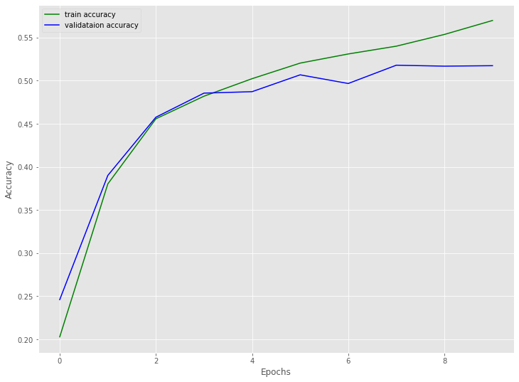
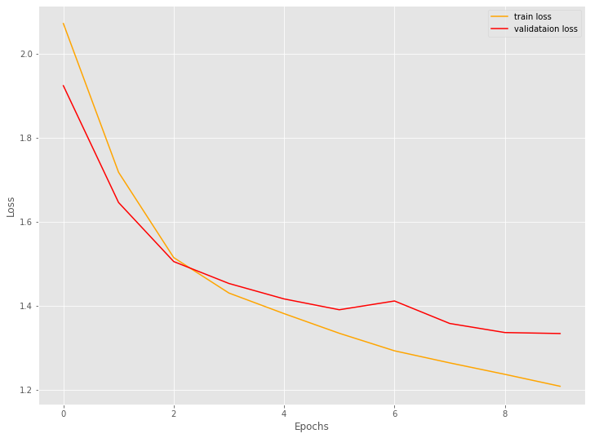

This are the graphs I got for GrayScale dataset of 11,000 plant leaf images for 10 epochs where training accuracy is 0.57 and validation accuracy is 0.51

RESULTS AFTER GIVING 60 EPOCHS FOR GRAYSCALE DATASET
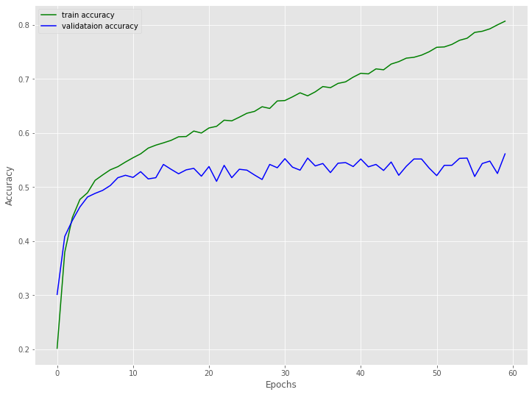
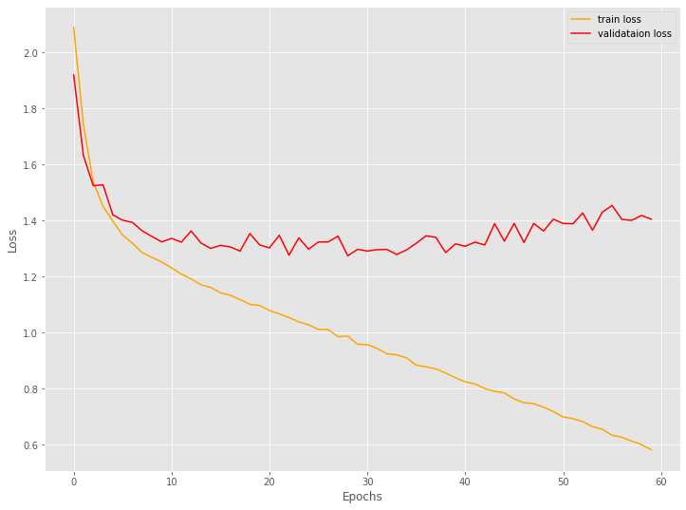

This are the graphs I got for GrayScale dataset of 11,000 plant leaf images for 60 epochs where training accuracy is 0.81 and validation accuracy is 0.57

RESULTS AFTER GIVING 30 EPOCHS FOR GRAYSCALE DATASET

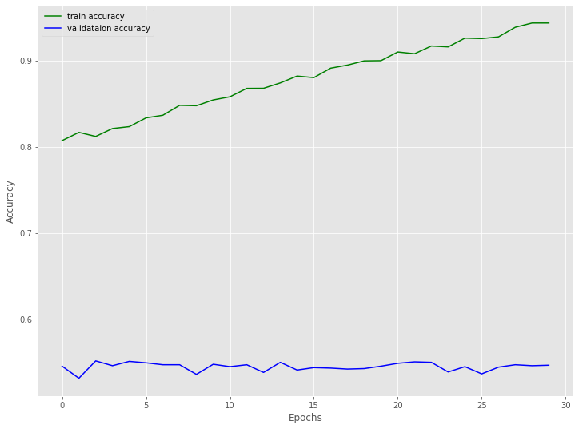
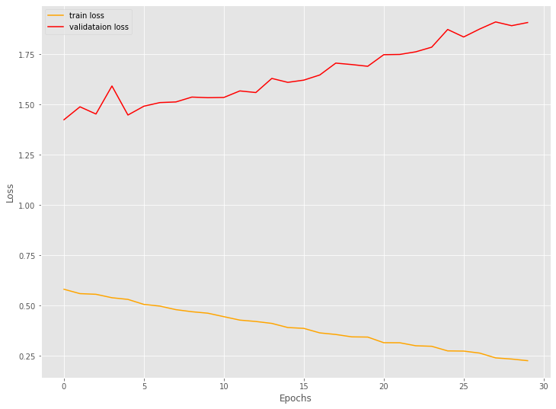
This are the graphs I got for GrayScale dataset of 11,000 plant leaf images for 30 epochs where training accuracy is 0.94 and validation accuracy is 0.56

RESULTS AFTER GIVING 10 EPOCHS FOR WHOLE DATASET

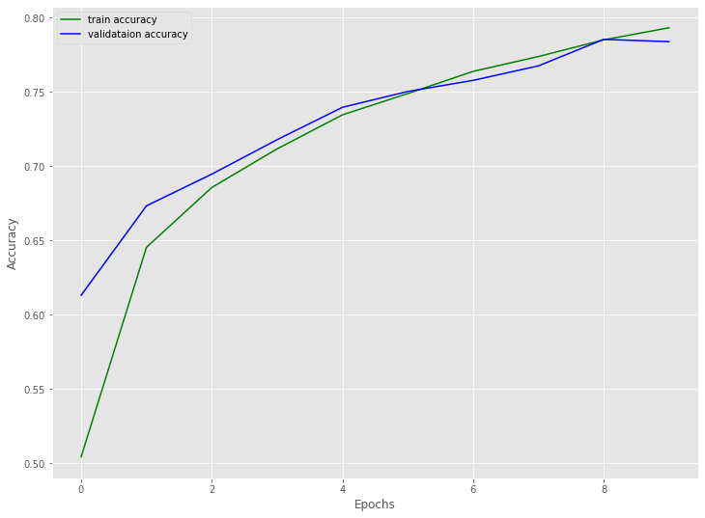
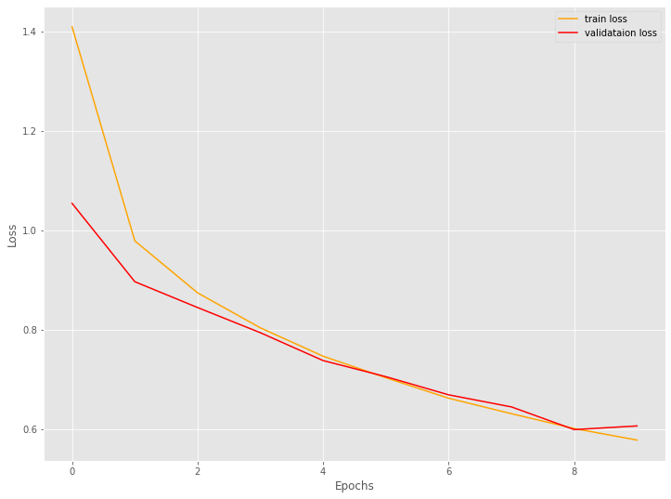
This are the graphs I got for whole dataset of 67,000 plant leaf images for 10 epochs where training accuracy is 0.79 and validation accuracy is 0.77

